Count all subsequences with sum K
Problem Statement: Given an array nums and an integer k. Return the number of non-empty subsequences of nums such that the sum of all elements in the subsequence is equal to k.
Examples
Example 1:
Input : nums = [4, 9, 2, 5, 1] , k = 10
Output : 2
Explanation : The possible subsets with sum k are [9, 1], [4, 5, 1].

Example 2:
Input : nums = [4, 2, 10, 5, 1, 3] , k = 5
Output : 3
Explanation : The possible subsets with sum k are [4, 1], [2, 3], [5].
Algorithm
- Use recursion to explore all combinations of elements that could contribute to the target sum.
- At each step, decide whether to include or exclude the current element.
- If the target becomes exactly zero, a valid subset has been found.
- If the target goes negative or the end of the array is reached without hitting zero, discard that path.
- Sum the results of both choices — inclusion and exclusion — to get the total number of valid subsets.
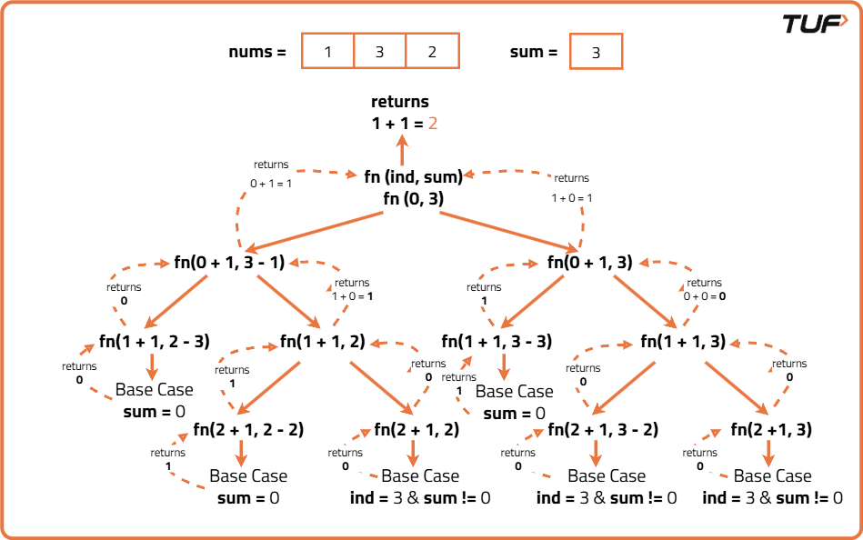
import java.util.List;
import java.util.Arrays;
import java.util.ArrayList;
class Solution {
// Helper function to count subsequences with the target sum
private int func(int ind, int sum, int[] nums) {
// Base case: if sum is 0, one valid subsequence is found
if (sum == 0) return 1;
// Base case: if sum is negative or index exceeds array size
if (sum < 0 || ind == nums.length) return 0;
// Recurse by including current number or excluding it from the sum
return func(ind + 1, sum - nums[ind], nums) + func(ind + 1, sum, nums);
}
// Function to start counting subsequences
public int countSubsequenceWithTargetSum(int[] nums, int target) {
return func(0, target, nums);
}
}
Time Complexity: O(2^n), where n is the number of elements in the array. This is because each element can either be included or excluded from the subsequence, leading to 2^n possible combinations.
Space Complexity: O(n), where n is the depth of the recursion stack. In the worst case, the recursion can go as deep as the number of elements in the array.

